

RoundTable Collaboration Environment

RoundTable™ Connected Services for Microsoft Outlook® 1.0 - User Guide

Table of Contents
1 Introduction 3
2 Installation 4
3 Configuration 7
3.1 Connecting to a RoundTable Server 7
3.2 Advanced Settings 8
3.2.1 Enable Automatic Synchronization 9
3.2.2 Retrieving completed tasks. 9
3.2.3 Remove other members deleted tasks 9
3.3 Synchronization 10
4 Discovering Functionality 13
4.1 Uploading tasks to RoundTable 13
4.2 Downloading tasks from RoundTable 13
4.3 Modifying RoundTable tasks 13
5 Application Removal 14
5.1 Disconnecting from Outlook 14
5.2 Uninstalling RoundTable CS for Outlook 15
5.3 Removing data files 15

Introduction
Welcome to the RoundTable Connected Services (CS) for Microsoft Outlook User Guide. Like all RoundTable Connected Services applications, RoundTable CS for Outlook provides deep integration and connectivity between RoundTable and Microsoft Outlook. This current version of RoundTable CS for Outlook integrates the Outlook task features, allowing you to share current activity information with your team and staying up to date with what’s going on else where. Throughout this guide, we will refer to the application as RoundTable CS for Outlook.

This user guide covers the following topics
- Applications Installation
- Connecting and Configuration
- Discovering Functionality
- Application Removal

If you are not able to find what you are looking for in this user guide, please contact the Dommoni Support group via e-mail at support@dommoni.com.

Installation

This section will take you through installing RoundTable Connected Services (CS) for Microsoft Outlook. Once you have completed the steps in this section, the application should be fully installed and verified and ready for configuration and use.

Note: This software relies on an application from Microsoft titled “.NET Framework”. If you do not already have a version of the .NET Framework installed, our installer application will walk you through downloading and installing the most recent version of the Framework.

- Open the Zipped file titled “RoundTable Connected Services for Microsoft Outlook.zip” and extract its contents. Please find the file titled “Setup.exe” and run it. Note: the installation will not continue if a previous version already exists. The installer will ask you to first remove that installation and then exit.

- Once you have run the installer, you should see a standard installer application like the following:
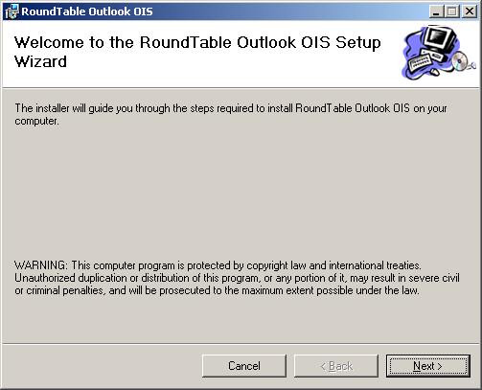

Click “Next” to begin the installation.

- The installer will next ask you where you would like to place the application within your local file system. Choose where you would like to install it if different from the default location. Once you have selected that and click next, the installation is ready to begin. Click next one more time for the installation to proceed.

- Once the installation is finished, you should see a screen similar to the following:
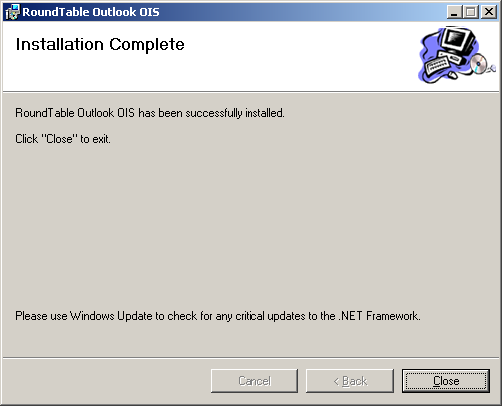

- Please start Outlook at this time to verify that the installation was successful. Once you have started Outlook, you should see a new menu item titled “RoundTable” as shown in the picture below.

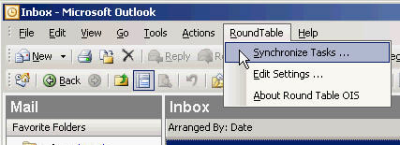

If the RoundTable menu is available, the application was correctly installed and functioning properly.

Configuration
This section will guide you through configuring your installation to connect to the RoundTable Server running on your Local Area Network and setting up specific parameters to allow you to begin using Connected Services for Outlook.

Connecting to a RoundTable Server
The configuration of Connected Services for Outlook is managed through the Outlook application interface. To begin configuring the application, please open outlook and expand the “RoundTable” menu. Click on the “Edit Settings…” menu item. Once you have done that, you should see a dialog alert that looks similar to the following:

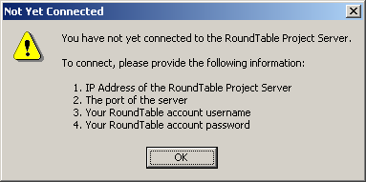

As the dialog states, in order to connect to RoundTable, you will need the following information:
- RoundTable Project Server IP Address or Windows network machine name
- The port the RoundTable Server is configured to run on (the default is 8080)
- Your RoundTable account information. (username and password)

Click the okay button once you have that necessary information and are ready to connect to the RoundTable Project Server. Once you have pressed the “OK” button, you should see the following window appear:

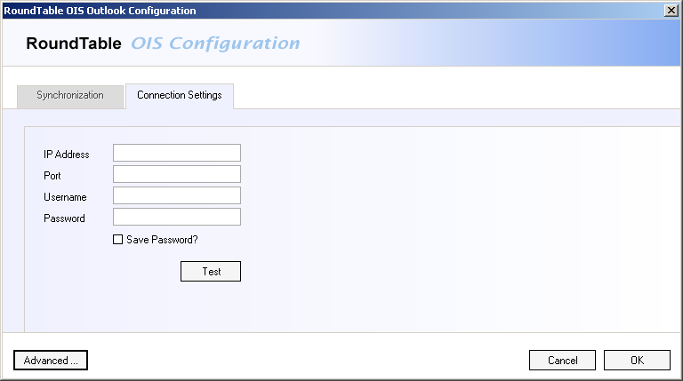

Enter in your connection information in the appropriate fields and press the “Test” button to verify that your connection is active. If you are able to successfully connect to RoundTable, you will be presented with the following dialog:

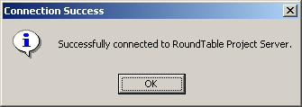

Note: Depending on machine speeds on both sides of the connection and the current state of the RoundTable Project server, it could take up to 30 seconds or more to initialize both systems and establish the application connection.

Pressing “OK” on the lower right corner of the “Connection Settings” tab will save your new configuration and close the window for you.

Advanced Settings
Advanced settings allow for fine grained control over the behavior of RoundTable CS for Outlook. In order to access the advanced settings interface, open the “Edit Settings” window from the RoundTable menu within Outlook. On the lower left of the window, click the “Advanced” button. You will then see the following window appear.

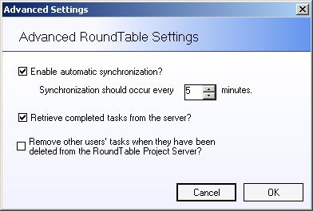

The functionality available on the Advanced Settings is discussed in the following subsections.

Enable Automatic Synchronization
Automatic Synchronization configures an autonomous process to connect to RoundTable and upload/download any tasks that might have been created either on RoundTable or within your local Outlook client. By enabling this feature, Outlook will automatically contact RoundTable at the period you specify. This allows you to constantly stay up to date with what your team members are doing and ensure that the shared tasks in your folder are always up to date.

Retrieving completed tasks.
This setting specifies weather or not to retrieve new tasks from RoundTable that are already in the complete state. If your synchronization time is set for an extended period or, you’ve disabled automatic synchronization, it is possible that when you execute a synchronization, there will be many tasks that are new to your Outlook client but have existed in RoundTable for an extended period already. RoundTable CS for Outlook will download those tasks and store them in the specified folder unless you specify otherwise.

Remove other members deleted tasks
Once a member deletes their task from RoundTable, this controls weather or not that action is reflected locally within Outlook. If you check the radio button, on the next synchronization, any task in your project folder that was once downloaded from RoundTable but no longer exists on RoundTable will be automatically deleted.

Synchronization
Synchronization Settings allow you to configure which projects you belong to should be synced and, to what folders in Outlook those projects will be synched to.

You can access the Synchronization Configuration interface by selecting “Edit Settings” from the “RoundTable” menu within Outlook. Select the “Synchronization” tab. Once you have done that, you should see the following interface.

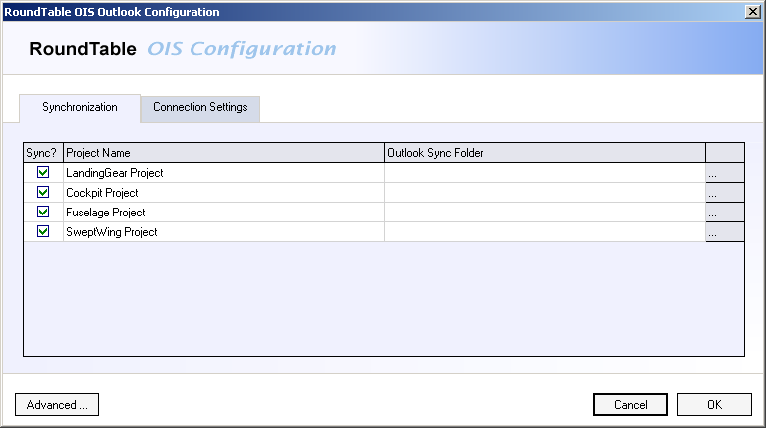

This list presents each project you are a member of and allows you to specify weather that project will be included in the synchronization process and the location it will be synchronized to. In order to exclude a project from a sync operation, uncheck the “Sync?” checkbox for the respective project.

The Sync Folder location can be set by selecting the “…” button to the right of the “Outlook Sync Folder” column. Once you have pressed the “…” button, you should see the following window appear.

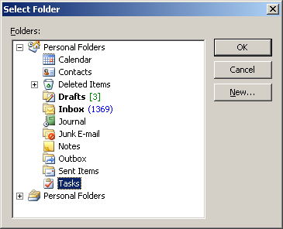

This window allows you to select an existing folder or create new one to be set as the task folder for the respective RoundTable Project. For demonstrative purposes, we will create 4 new folders under the default “Task” folder to be the destination for our sample projects. Select the “New…” button on the right side of the dialog box. You should see the following:

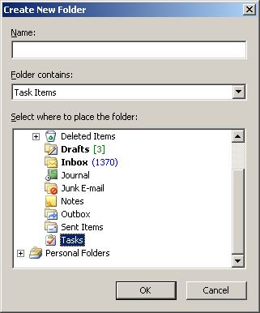

Notice that the “Folder contains” field is set to “Task Items”. You will want to leave this setting as the “Outlook Sync Folder” field will only accept a folder value that is a tasks folder. Give the folder a meaningful name and press “OK”. You will then return to the original “Select Folder” window. Press the “OK” button in the upper right of that window as well. You should then return to the Configuration screen however, it will now contain the folder you have selected as a path, as shown below.

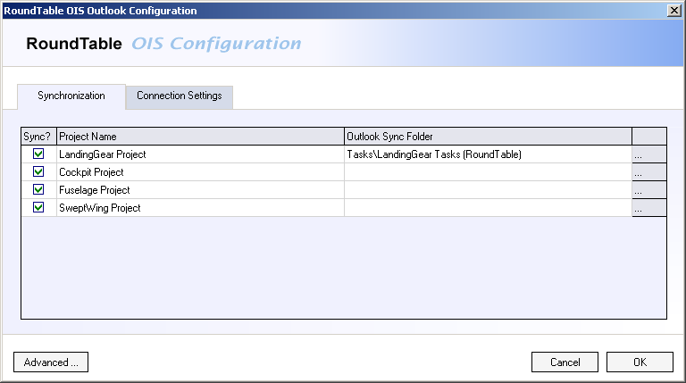

Note: Projects that do not have a Sync folder specified cannot be synchronized when that process is run, either automatically or manually.

If you have other projects, be sure to configure the task folders for those as well.

Discovering Functionality
This section will help you discover the day-to-day features of RoundTable CS for Outlook and provide you with a context for using those features.

Uploading tasks to RoundTable

Downloading tasks from RoundTable

Modifying RoundTable tasks

Application Removal
This section will guide you though uninstalling and completely removing RoundTable Connected Services for Microsoft Outlook from your computer. This happens in 3 steps as listed below.
- Disconnecting from Outlook
- Uninstalling the application
- Removing data files

Disconnecting from Outlook
The first step in uninstalling or completely removing RoundTable CS for Outlook is to disconnect it from Outlook. In order to do this, open the “Options” window from the “Tools” menu in Microsoft Outlook. Select the “Other” tab and click on the “Advanced Options” button.
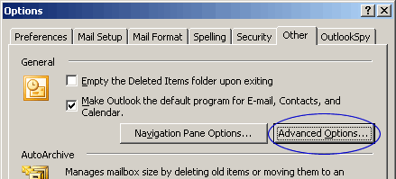

Once you have clicked on the “Advanced Options” button, you will be presented with a new window.

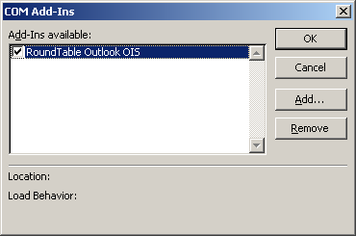

Uncheck the “RoundTable Outlook OIS” check box and, with the entry still selected, press the “Remove” button. Then press “OK”.

You have now successfully disconnected RoundTable CS for Outlook from Microsoft Outlook.

Uninstalling RoundTable CS for Outlook
Once you have completed the steps in the previous section, you are ready to uninstall RoundTable CS for Outlook. To do this, open the Windows Control Panel and click on the “Add/Remove Programs” icon. Find the entry for RoundTable CS for Outlook (titled “RoundTable Outlook OIS” in older versions).

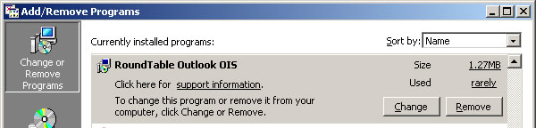

Press the “Remove” button. You will then be prompted to verify that this is what you want to do. Press “Yes” to begin the Uninstall process.

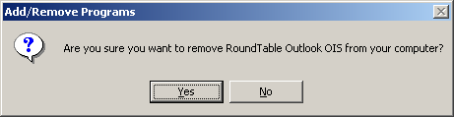

You have now successfully removed the application files from your computer.

Removing data files
Once you have removed the application files, there are two files that will remain in your local directory. These are settings and log files which where generated by the application and are left behind in case you whish to reinstall RoundTable CS for Outlook. In order to remove these files, delete the RoundTable CS for Outlook directory from underneath your Program Files directory.

